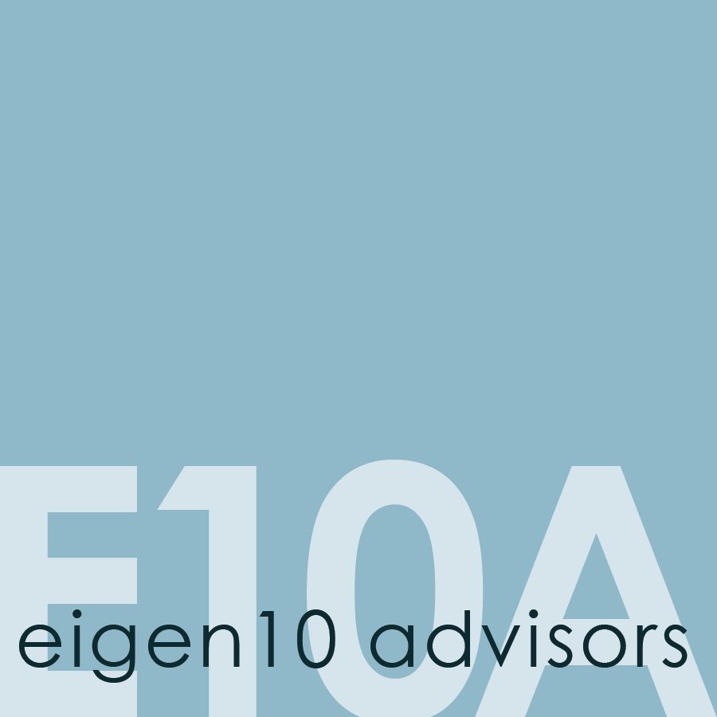
Paige Mueller
Managing Director
Eigen10 Advisors, LLC

310.923.2909
www.eigen10.com
pmueller@eigen10.com

Paige Mueller has decades of experience working with both limited partners and general partners. She works with clients focusing on a variety of projects, including portfolio strategy, market analysis and forecasting, as well as business and marketing strategies. She previously led the development and growth of a pension consulting business that provided manager selection and sourcing for funds, separate accounts and joint ventures, as well as investment analysis, term negotiations, and portfolio strategy. There, she sourced and reviewed investment underwriting for more than $1 billion in new investments, and created a reporting and risk management system for a $2.5 billion separate account portfolio.
At GIC Real Estate, she worked on a multi-billion dollar global real estate portfolio, including public and private, debt and equity instruments. There she specialized in global portfolio strategy and risk analysis, market analyses and forecasting in multiple countries, asset and value reviews, and investment reviews. She previously worked at LaSalle Investment Management, providing support for investment, brokerage, REIT, site selection teams, and knowledge management.
​Paige graduated with an MBA in Finance from Indiana University and is a frequent industry publisher and speaker. She has held leadership positions in a number of industry organizations including Vice-Chair of the ULI Global Exchange Council, President of the Real Estate Research Institute, Co-Chair of the PREA Research Affinity Group, and Editor-in-Chief of the Counselors of Real Estate ‘The Counselor’ publication, among others. She is a Lecturer at UC Berkeley, and has received recognition as a Hoyt Fellow and Counselor of Real Estate.

